New here? Start with the 5-minute summary.
A survey by g0v.tw Jothon

Taiwan Civic Tech Ecosystem and Needs Survey
127 valid responses: where Taiwan's civic tech participants come from, where they get stuck on projects, and what makes them want to stay.
Author: Claire Cheng (鄭婷宇) | Data: 127 valid responses collected up to 20 July 2026
License: CC BY 4.0, by g0v.tw Jothon & Claire Cheng

I. Background: what we wanted to know
This report analyzes a survey sent out in 2026 by Jothon, a working group within g0v.tw¹, Taiwan's grassroots civic tech community. With personal details removed, the raw responses are open to everyone under CC BY 4.0, credited to the survey respondents ("臺灣公民科技推廣問卷填寫者").
The survey gathered 127 responses up to 20 July 2026. We wanted to see what Taiwan's civic tech community really looks like: who takes part, and what people at different levels of involvement need and struggle with. By finding out what draws people in and where they get stuck, we hope to help g0v.tw Jothon put its resources where they matter most and keep Taiwan's civic tech community thriving.
Put simply, civic tech means using technology and digital tools to make public life better. It can take many forms: building a small tool that makes it easier to take part in public affairs or use public services, or bringing people together to discuss policy and using open data to improve how government works. Open data here means data that governments or organizations publish for anyone to freely use. Examples include the "mask map", which helped people in Taiwan find face masks during COVID-19, and vTaiwan, where people with different views discuss policy online.
If you want to go straight to projects you could join, Civic Tech Taiwan, a database run by g0v.tw Jothon, lists many projects and guides to getting involved (in Chinese). It is a good place to start.

Where to start, based on who you are
Pick the role that fits you best. Or skip this and read from start to finish.
I'm new and still getting to know the community
Chapter 7 found that the number one reason newcomers don't get in is "not knowing which projects exist", not a lack of skills. Start with Chapter 1 to see who these people are and where they are, then Chapter 7 to see where the way in breaks, and finally Recommendation 1.3 for resources at each stage.
Start with:
- Chapter 1: Who they are and where they are
- Chapter 7: Where the way in is, and where it breaks
- Recommendation 1.3: Resources for each level of involvement
I'm working on (or have worked on) a civic tech project
These three chapters focus only on "the 47 who have worked on a project": the problems they actually ran into (Chapter 3), how their motives changed over time (Chapter 4), and the resources they had to work with (Chapter 5). They are closest to what you are dealing with now.
Start with:
- Chapter 3: What wears Builders down
- Chapter 4: Motives change, and which one fades most
- Chapter 5: The resources projects use most
I might provide resources, or want to support the community
Chapter 6 covers how funders themselves assess projects. Recommendation 1.4 sums up forms of support beyond money. Section 3.2 is a reminder: the more say people have, the more likely they are to burn out, a risk worth watching when you support a project over the long term.
Start with:
- Chapter 6: How funders assess projects
- Recommendation 1.4: How to support the civic tech ecosystem
- Section 3.2: The more say people have, the more likely they are to burn out

II. Summary: four key findings
1. Stalled projects and burned-out core members are the biggest pain for Builders
At every g0v.tw bimonthly hackathon, you see plenty of projects looking for people to "jump in" (community slang for joining a project) and build with them. But for people who work on projects, the biggest headache is not a shortage of people. It is keeping progress steady, getting results to make a difference, and core members burning out. In this survey, 32% (15/47) of the 47 Builders had no active project when they answered. Progress that stops and starts, results that don't land, and a few people holding on for a long time: together, these three are the biggest obstacle. Among these respondents, those with more say in a project tend to be more likely to burn out. This is quite likely because more say usually means more effort and time, which wears people out more.
2. Believing in what a project wants to do, and making like-minded friends, make people more likely to stay
The strongest pull, both for bringing people into civic tech projects and for keeping them, is believing in what the project aims to achieve. It is the most common reason people join, and the most lasting reason they stay. Another change worth noting: the motive "build up a portfolio and sharpen my skills" grew from 6 people at first to 9 now, a relative increase of 50%. This shows that some people keep taking part to build their skills.
3. Not knowing what projects exist, and having no one to show the way, are the biggest barriers for newcomers
Among the 26 Curious who have not taken part, the most common barriers were "don't know which projects or issues exist" and "no one around to show me the way, and I worry I won't fit in or be any help", followed by "don't know how to join or where to start". "I feel I'd need to know how to code; the bar is too high", which many people assume is the main obstacle, actually came only fourth. Of all respondents, 65% regularly see news from at least one official g0v.tw channel, but seeing the news does not mean knowing what you can do, or knowing someone you can ask.
4. A clearly explained problem and a working prototype attract support most easily
Among the 27 respondents who have given financial support to civic tech projects, what mattered most when deciding whether to support one was "the problem it tackles is important and clearly explained", and whether it "matches issues I care about". More than half of these funders also felt that projects "still at a very early stage, just an idea" have the hardest time getting resources. This makes sense: projects that have not yet turned an idea into a working prototype usually find it harder to win funders over.

III. Findings

1. People from many walks of life, over 60% living in Taipei or New Taipei
This chapter looks at the backgrounds of the people who answered the survey and where they usually spend their time.

1.1 Who they are and where they are
Key point: Of the 127 respondents, only 47 have actually worked on a project. Most have not.
The 127 respondents fall into three groups
Base: all 127 respondents (green: the Curious, orange: the Users, blue: the Builders)
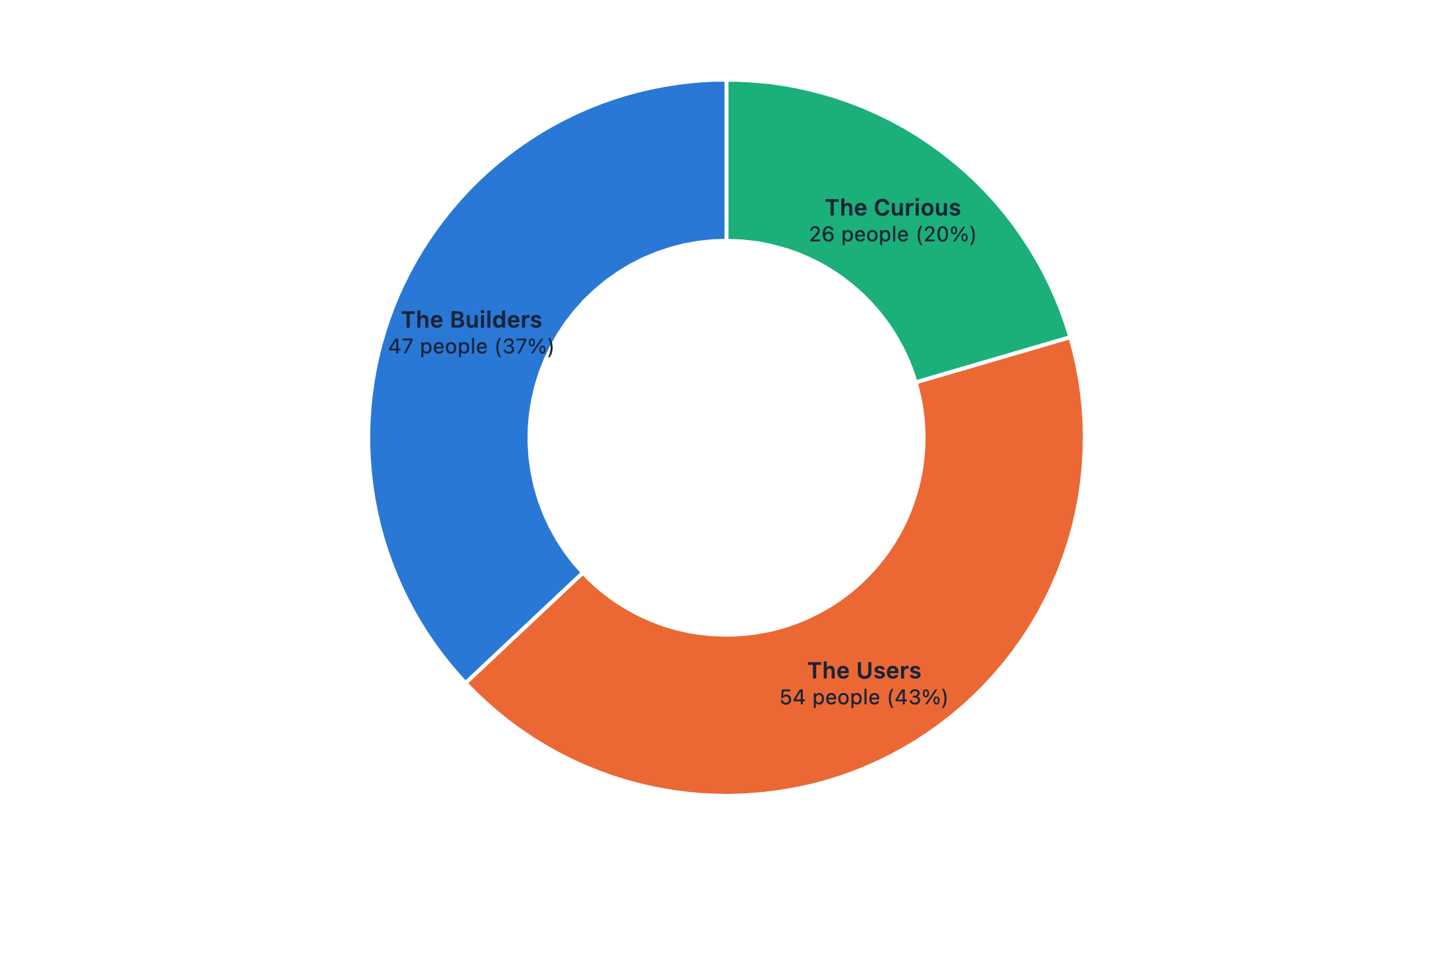
Where respondents live
All respondents, N=127. Over 60% live in Taipei or New Taipei
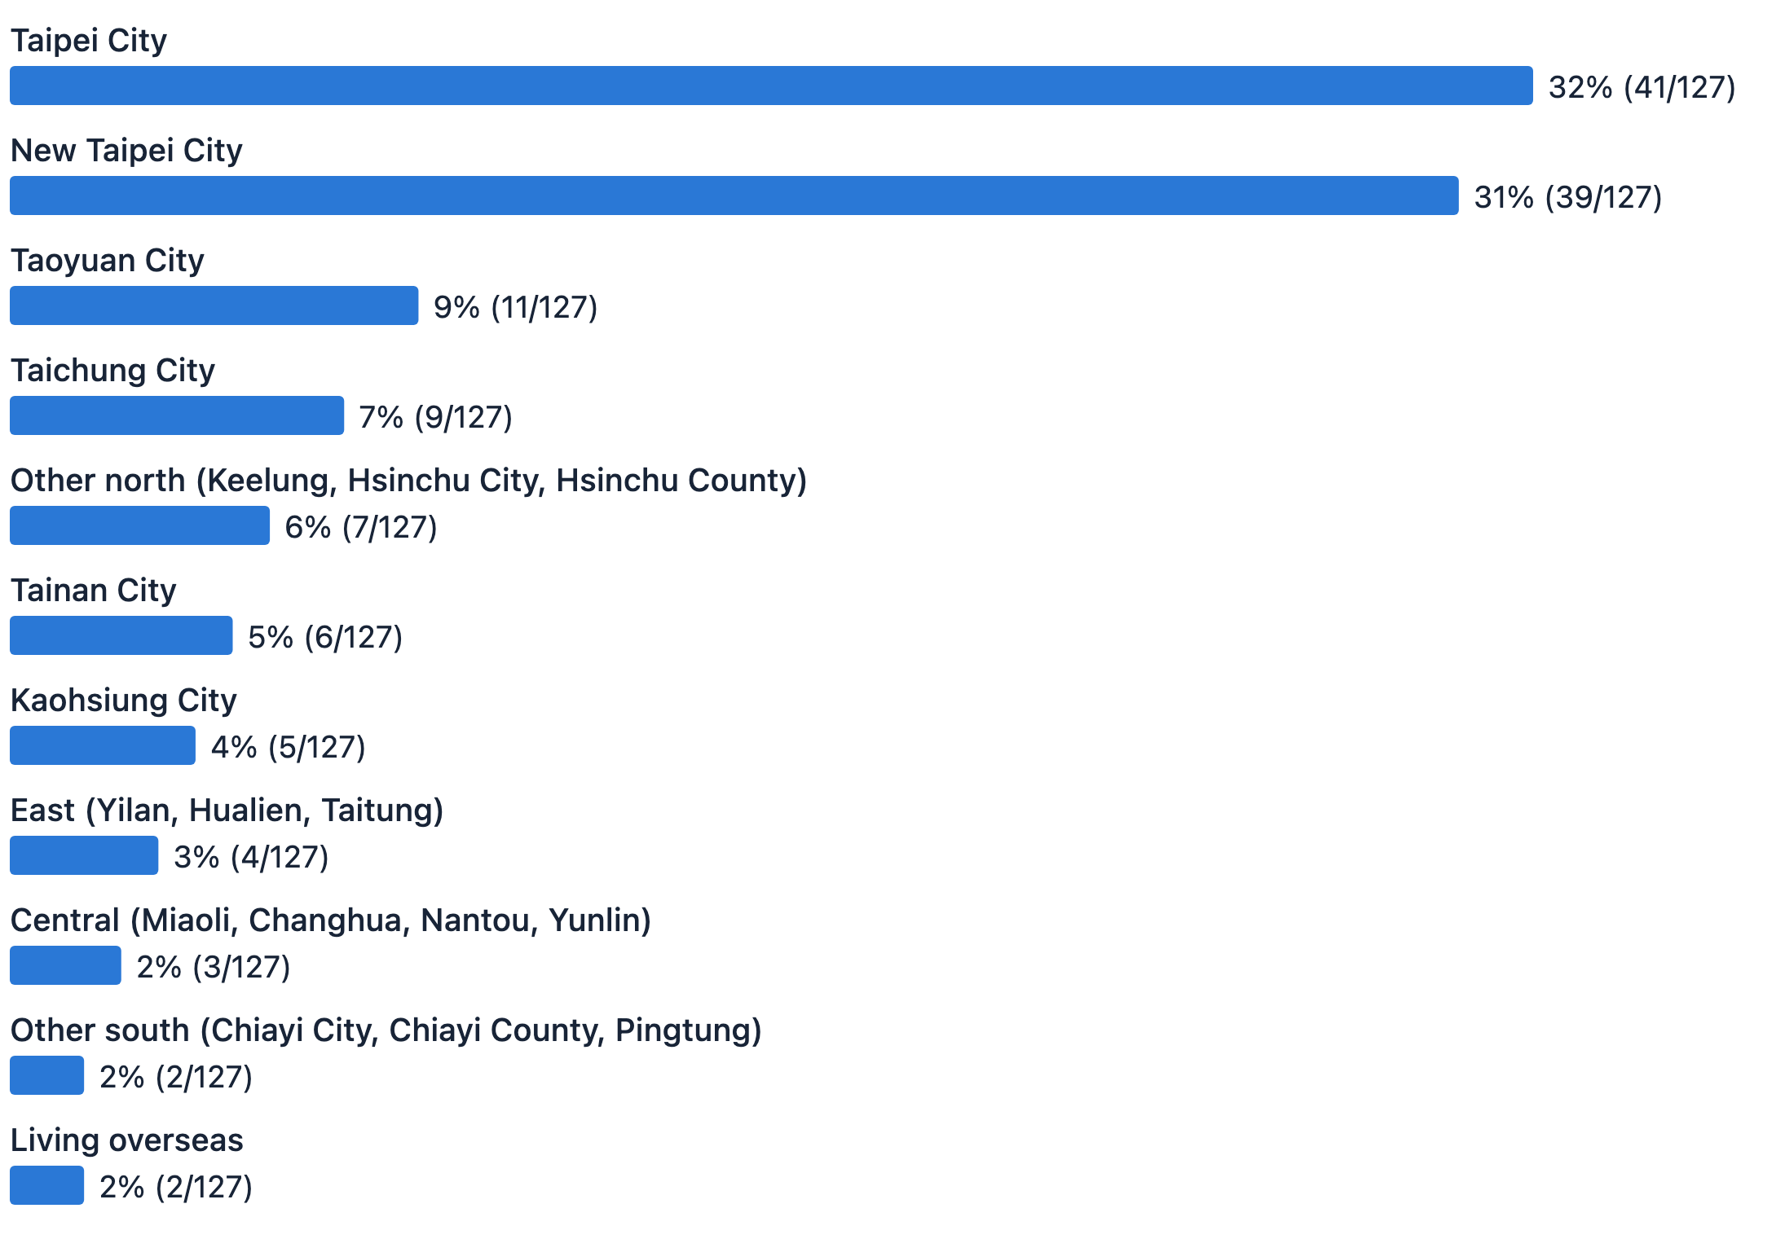
Base: all 127 respondents
The 127 responses fall roughly into three groups:
- The Curious: 26 people who have heard of or seen civic tech, but have not actually got involved.
- The Users: 54 people who know the community but have not worked on any project.
- The Builders: 47 people who have actually worked on at least one civic tech project. Later questions about "what got stuck" and "what keeps people going" were answered only by these 47, because they asked about specific project experience.
Most respondents are aged 31 to 50: 35% are 31 to 40 and 29% are 41 to 50, while only 5.5% are 20 or under. By gender, 50% are men, 41% women, and 9% other or prefer not to say.
Respondents come from a wide range of work backgrounds: freelancers and nonprofit workers are the largest groups, at 20% each, followed by schools or research institutions (16%), companies or startups (16%), students (13%) and the public sector (8%). Of the 55 who told us more about their organization, 27% work at nonprofits and associations, 25% at academic and research institutions, and 22% at companies and startups. People who care about civic tech come from many industries and organizations, not one field.
But looking only at where people live understates how far their connections reach. The survey also asked "Besides where you live, which regions do you have close ties to?" 63 people answered: 34 named places in central, southern or eastern Taiwan (such as Taichung, Tainan, Kaohsiung and Hualien), and 14 mentioned places overseas. Even among the 79 who live in Taipei or New Taipei, 20 also have close ties to central, southern or eastern Taiwan, and 8 to places overseas. Most respondents live in the capital region, but their personal networks reach much further.

1.2 Have all the people who care about civic tech been to g0v.tw?
Key point: Of all respondents, 47% have never been to a g0v.tw event. Getting the news does not mean knowing what you can do, or having someone to ask.
Of all respondents, 47% (60/127) have never been to a g0v.tw event. Even among the 47 Builders, 28% (13/47) have never been to a g0v.tw event.
When asked "Where do you get information about civic tech?", 59% chose "nonprofit organizations", more than the 54% who chose "open source communities (including g0v.tw)". g0v.tw is an important hub in the ecosystem, but not the only way in.

2. Most are lightly involved, mainly as users

2.1 What roles have people played in civic tech projects?
Key point: Of the 101 who have had contact with civic tech, nearly nine in ten have been a "User". Only 33% have actually helped build or maintain a project.
Roles people have played (more than one answer allowed; from lightest to deepest)
Base: 101 who have had contact with civic tech (more than one answer allowed, so totals exceed 100%)
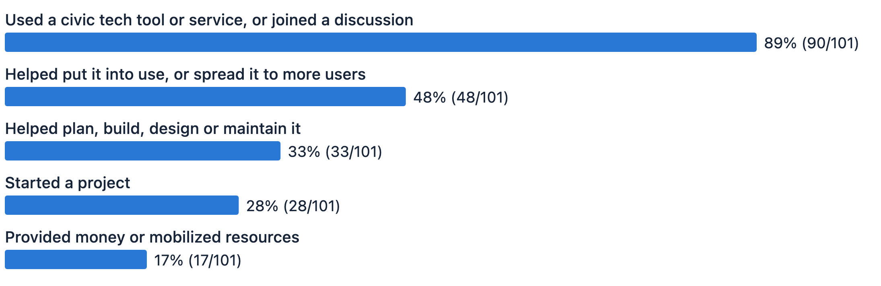
Base: 101 who have had contact with civic tech
Depth of involvement: four in ten are on the first step
Base: 101 who have had contact with civic tech (the grey option is not on the depth scale and is not weighted)
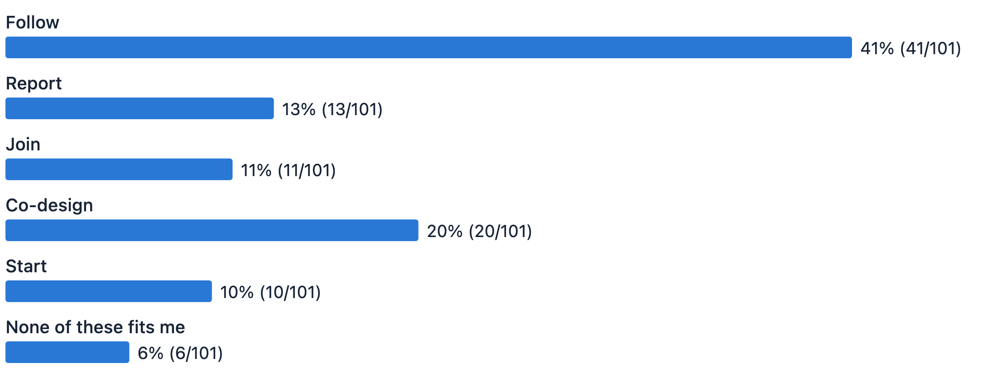
Base: 101 who have had contact with civic tech
The survey asked which roles people have played in civic tech projects (more than one answer allowed). Among the 101 who have had contact with civic tech: 89% have used a tool or joined a discussion, 48% have helped put something into use or spread it, 33% have helped plan, build, design or maintain a project, 28% have started a project, and 17% have provided money or mobilized resources.
46 people (46%) ticked only one role; just 10 (10%) ticked all five. A large group sticks to one thing, while a small group does almost everything, and the spread in between is uneven. The more deeply involved people are, the more roles they usually take on at once.
The survey also asked a single-choice question: "Which statement best describes what you do in the civic tech community?" The five options run from the least to the most say over a project's direction: Follow (read about issues and results), Report (provide information when a project asks, such as road conditions or pollution data), Join (help get things done on projects others started), Co-design (define the problem and design the solution with others) and Start (spot a problem, find partners and launch a project). Another 6 people chose "None of these fits me", which is left off this scale. Of the 101, 41% chose the lightest level, "Follow".
Of the 46 who ticked only one role, 42 ticked the one with the lowest bar, "used a tool or joined a discussion", and 30 of them were at the "Follow" level of involvement. "Doing only one thing" largely reflects "being lightly involved".
One more thing worth noting: people who build projects have not necessarily used other people's civic tech. 38 people ticked "helped plan, build, design or maintain" or "started a project" (counting those who ticked both only once), and 7 of them (18%) did not tick "used a tool or joined a discussion".

2.2 What are these projects about?
Key point: Among the 47 Builders, the most common project topic was environment and ecology (15%). The rest are spread across 10 areas such as education, disaster response and political oversight.
Each of the 47 described in one sentence "what problem their most recent project aims to solve". After sorting these by hand into 11 categories, the most common topic was environment and ecology, with 7 people (15%). Second was "Other", with 6 people (13%), covering topics such as housing, health care, energy and digital identity. Next came education and learning, community-building and collaboration tools, and disaster prevention and public safety, with 5 people each (11%); then political oversight and open parliament, land use, cities and local communities, and public discussion and opinion tools, with 4 each (9%). The rest were transport and roads (3 people), working with government and civil servants (2), and fact-checking misinformation (2).
Of these, 15 people's projects deal with topics that require working with the public sector. This fits with Chapter 7, where "Working with government" was the most wanted event.
The survey looks at the same people from two angles: their overall experience, not tied to any one project (this chapter), and "the project they worked on most recently" (Chapters 3 to 5). The two are kept separate, because someone who often starts projects in the community may not be the founder of the project they worked on most recently.

3. What wears Builders down most: stalled progress and burned-out core members

3.1 What troubles people most when working on a project?
Key point: Among the 47 Builders, the top three problems were keeping progress steady, getting results to make a difference, and a few people holding everything up. "Not finding partners", the one most people would think of first, ranked only fourth.
How much each difficulty troubles people (all ratings from 1 to 5)
Sorted by how many rated it 3 or higher (there was no “not experienced” option, so a rating of 1 covers both “never happened” and “happened but had no impact”)
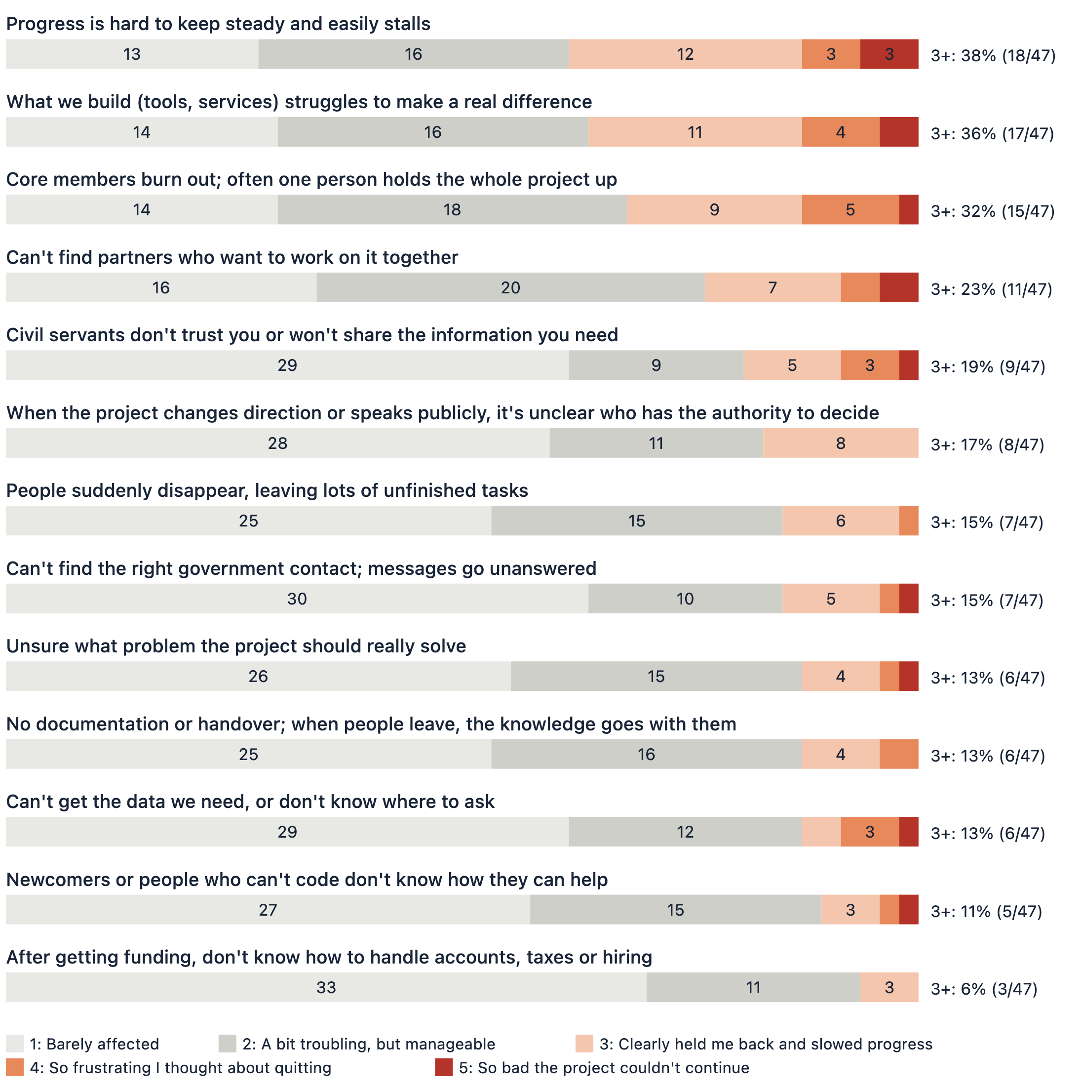
Base: 47 Builders (all 47 rated every item)
Only the 47 Builders answered these questions. The survey listed 13 common difficulties and asked them to rate each one. We use two measures: a rating of 3 or higher (3, 4 and 5 combined) means the problem really held back progress; 4 or higher (4 and 5 combined) means it was bad enough to make them want to quit.
The top three problems were keeping progress steady, getting results to make a difference, and a few people holding everything up. "Can't find partners who want to work on it together", the one most people would think of first, ranked fourth. These three may feed into each other: when momentum breaks, results are slow to appear; without results, it is harder to show the project is worth the effort; fewer people step in, and the load falls back on the few.

3.2 The more say people have, the more likely they are to burn out
Key point: Among the Builders there is a pattern: the more say someone has in a project, the more likely they are to feel burned out. Of the 10 who started their own project, 6 (60%) said core-member burnout clearly held back progress.
Your position in the project and how much say you have (based on the depth-of-involvement question)
Your position in the project | Say in direction | Core members burning out | Results struggle to make a difference
Joined someone else's project; the founder sets the direction | Least | 12% | 12%
Define the problem and design the solution with others | Shared | 33% | 44%
Started it myself: spotted the problem, found people, got it going | Most | 60% | 50%

Among these respondents, those more deeply involved and with more say were more likely to face core-member burnout (quite likely their own) and to worry that the results would not make a difference.

3.3 Decision-makers don't see what newcomers struggle with
Key point: When planning how to bring newcomers in, asking only founders and decision-makers may not get you the answer: it is usually not a problem they face themselves.
On the item "Newcomers or people who can't code don't know how they can help", the people who feel it most are at the shallow end: 2 of 6 (33%) in the Report group, 1 of 5 (20%) in the Follow group, 1 of 8 (12%) in the Join group, 0% (0/18) in the Co-design group, and 1 of 10 (10%) in the Start group.
People less involved were more likely to worry about how newcomers who can't code could help. As people gain more say in a project, this worry broadly gets lower. So if you want to plan how to bring newcomers in, asking only founders and decision-makers may not get you the answer, because it is not a problem they face themselves.

3.4 What did people actually do about these difficulties?
Key point: The two most common responses pointed in opposite directions: reaching out for help, or slowing down and lowering expectations. Of the 28 who answered, 11 chose to lower their expectations or took no particular action.
What people did when facing difficulties (28 respondents; some mentioned more than one)
What they did | People
Reached out for help (contacts, experts, local organizations) | 6
Lowered expectations and slowed down | 5
Built up skills myself or relied on tools | 4
Talked it through as a team and set a regular rhythm | 4
Promoted the project to reach more people | 4
No particular action, or none yet | 3
Described the difficulty but no action | 3
Handed over or stepped back | 1
Wrote documentation to avoid handover gaps | 1

The survey also asked an optional question, "Did you take any action to deal with these difficulties?" 28 people answered.
The two most common responses pointed in opposite directions: reaching out for help (6 people), or slowing down and lowering expectations (5 people). The second group mostly let things take their course rather than push for progress. Counting them together with the 6 who took no particular action or only described the difficulty, 11 of the 28 either chose to lower their expectations or did nothing in particular.

4. Four in ten changed their motives, and the sense of belonging faded most

4.1 What keeps people working on projects?
Key point: Believing in what a project aims to achieve is the core reason people join and keep contributing.
First motive → ongoing motive (the 47 Builders, more than one answer allowed)
Motive | Chose it when they first joined (people) | Retention rate | Net change
Believe in what it is trying to achieve | 39 | 92% | 0%
Identify with the community and want to be part of it | 20 | 70% | −15%
Just for fun | 16 | 81% | −6.3%
Meet new people and like-minded friends | 13 | 92% | +15.4%
People around me were doing it, so I joined | 12 | 67% | 0%
Build a portfolio, sharpen skills or build a reputation | 6 | 83% | +50.0%

Why people stay: differences by age
Each bar shows how far an age group's share is from all 47 Builders, in percentage points. Right means higher than overall; left means lower.
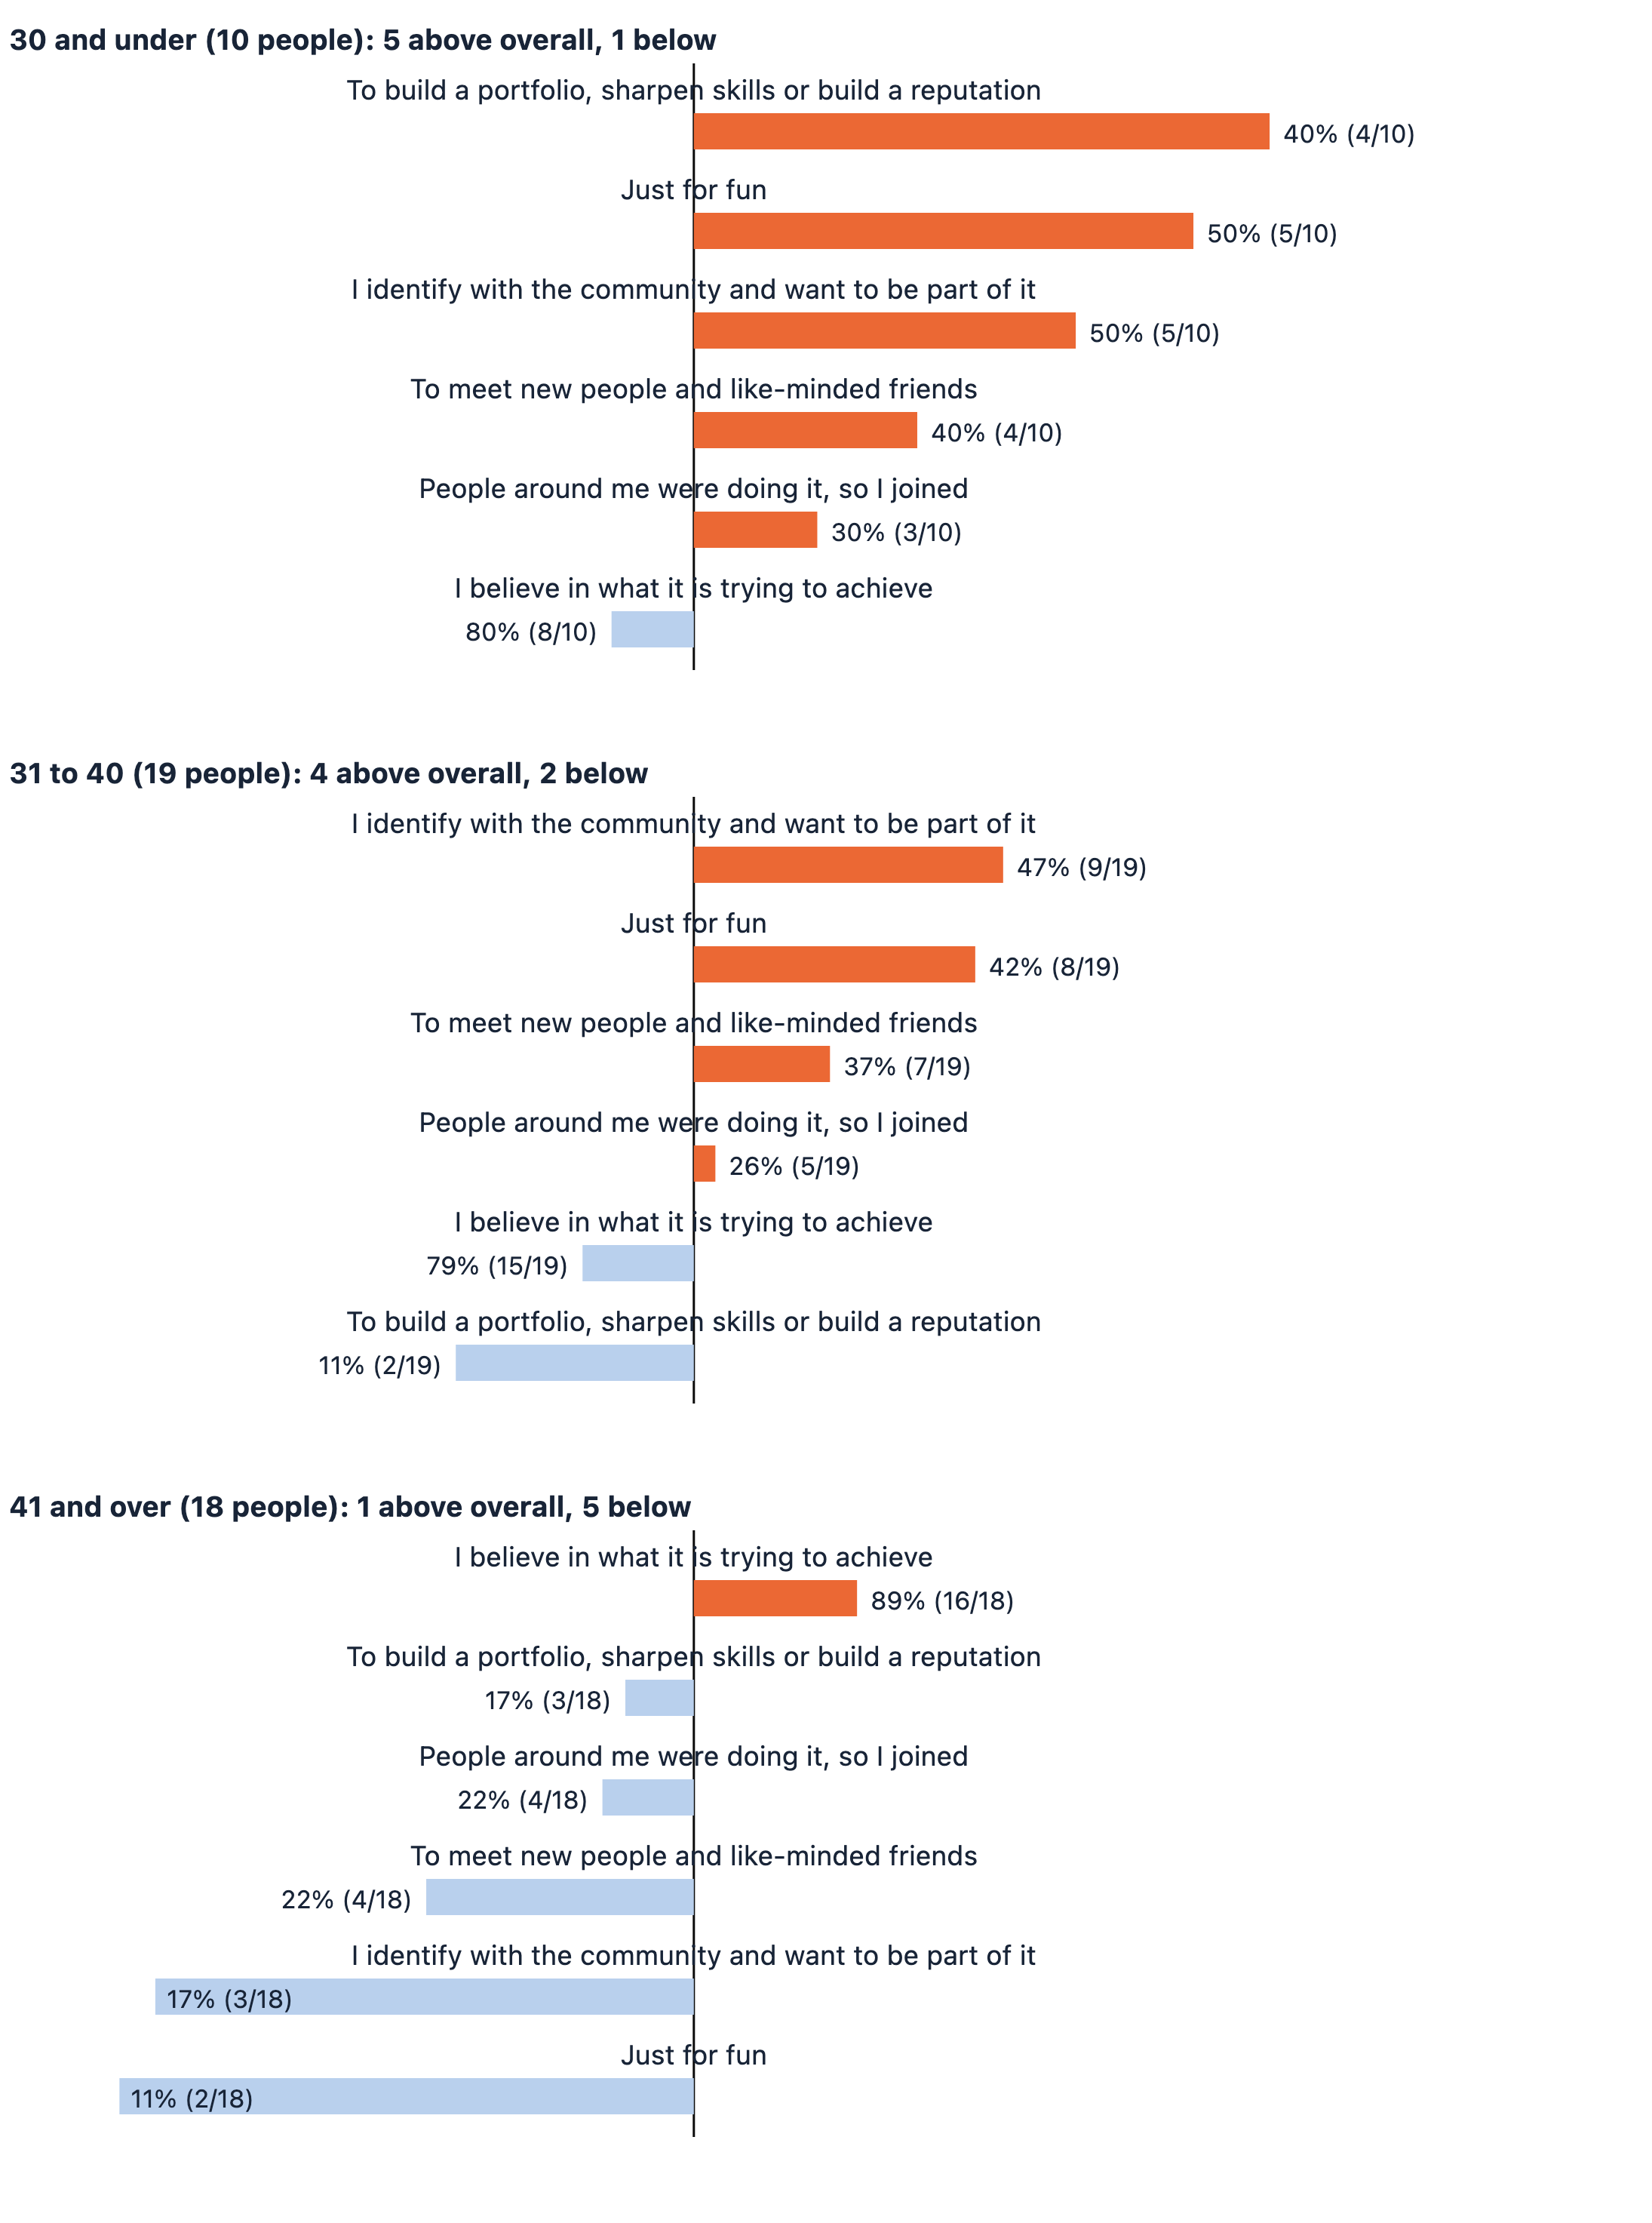
The three age groups have 10, 19 and 18 people (more than one answer allowed)
"Retention rate" means the same person chose the same motive both times. "Net change" looks at how the number of people rose or fell: those who chose a motive when they first joined, plus those who picked it up later, minus those who no longer give it as a reason, shown as a percentage of the starting number. The two look at different things, so they rank motives differently. For example, "People around me were doing it, so I joined" had the lowest retention rate of the six, at 67%; but because the 4 people who dropped it matched the 4 who picked it up, its net change is still 0% and the total did not change.
Believing in a project's goal is the most common reason people take part, and the reason that best sustains them over time.
Identifying with the community had the biggest net drop of the six motives: 20 people chose it at first, and 17 do now. Of the original 20, 6 (30%) no longer give it as a reason, while 3 others picked it up later. This is worth looking into: did the people who stopped naming the community as a reason gradually lose their sense of belonging along the way?
Only two motives grew overall: "building a portfolio and sharpening skills" and "Meet new people and like-minded friends". The first grew more, and it is a goal-oriented motive.
Looking only at why people stay, there are some differences by age. Among those 30 and under, 4 of 10 (40%) chose "building a portfolio and sharpening skills", higher than 19% across all Builders. Among those 41 and over, "believing in the goal" stands out at 89%, and the biggest gaps are "just for fun" and "identifying with the community", 21 and 20 percentage points below the overall figures.
But each age group has only 10 to 19 people, so these generational differences are an early observation, worth tracking again as more responses come in.

5. Personal networks are the resource projects use most

5.1 Which resources do projects use most?
Key point: Among the 47 Builders, personal networks were the most used resource (66%), ahead of funding (47%).
Resources the Builders have used
Base: 47 Builders (more than one answer allowed, so totals exceed 100%)
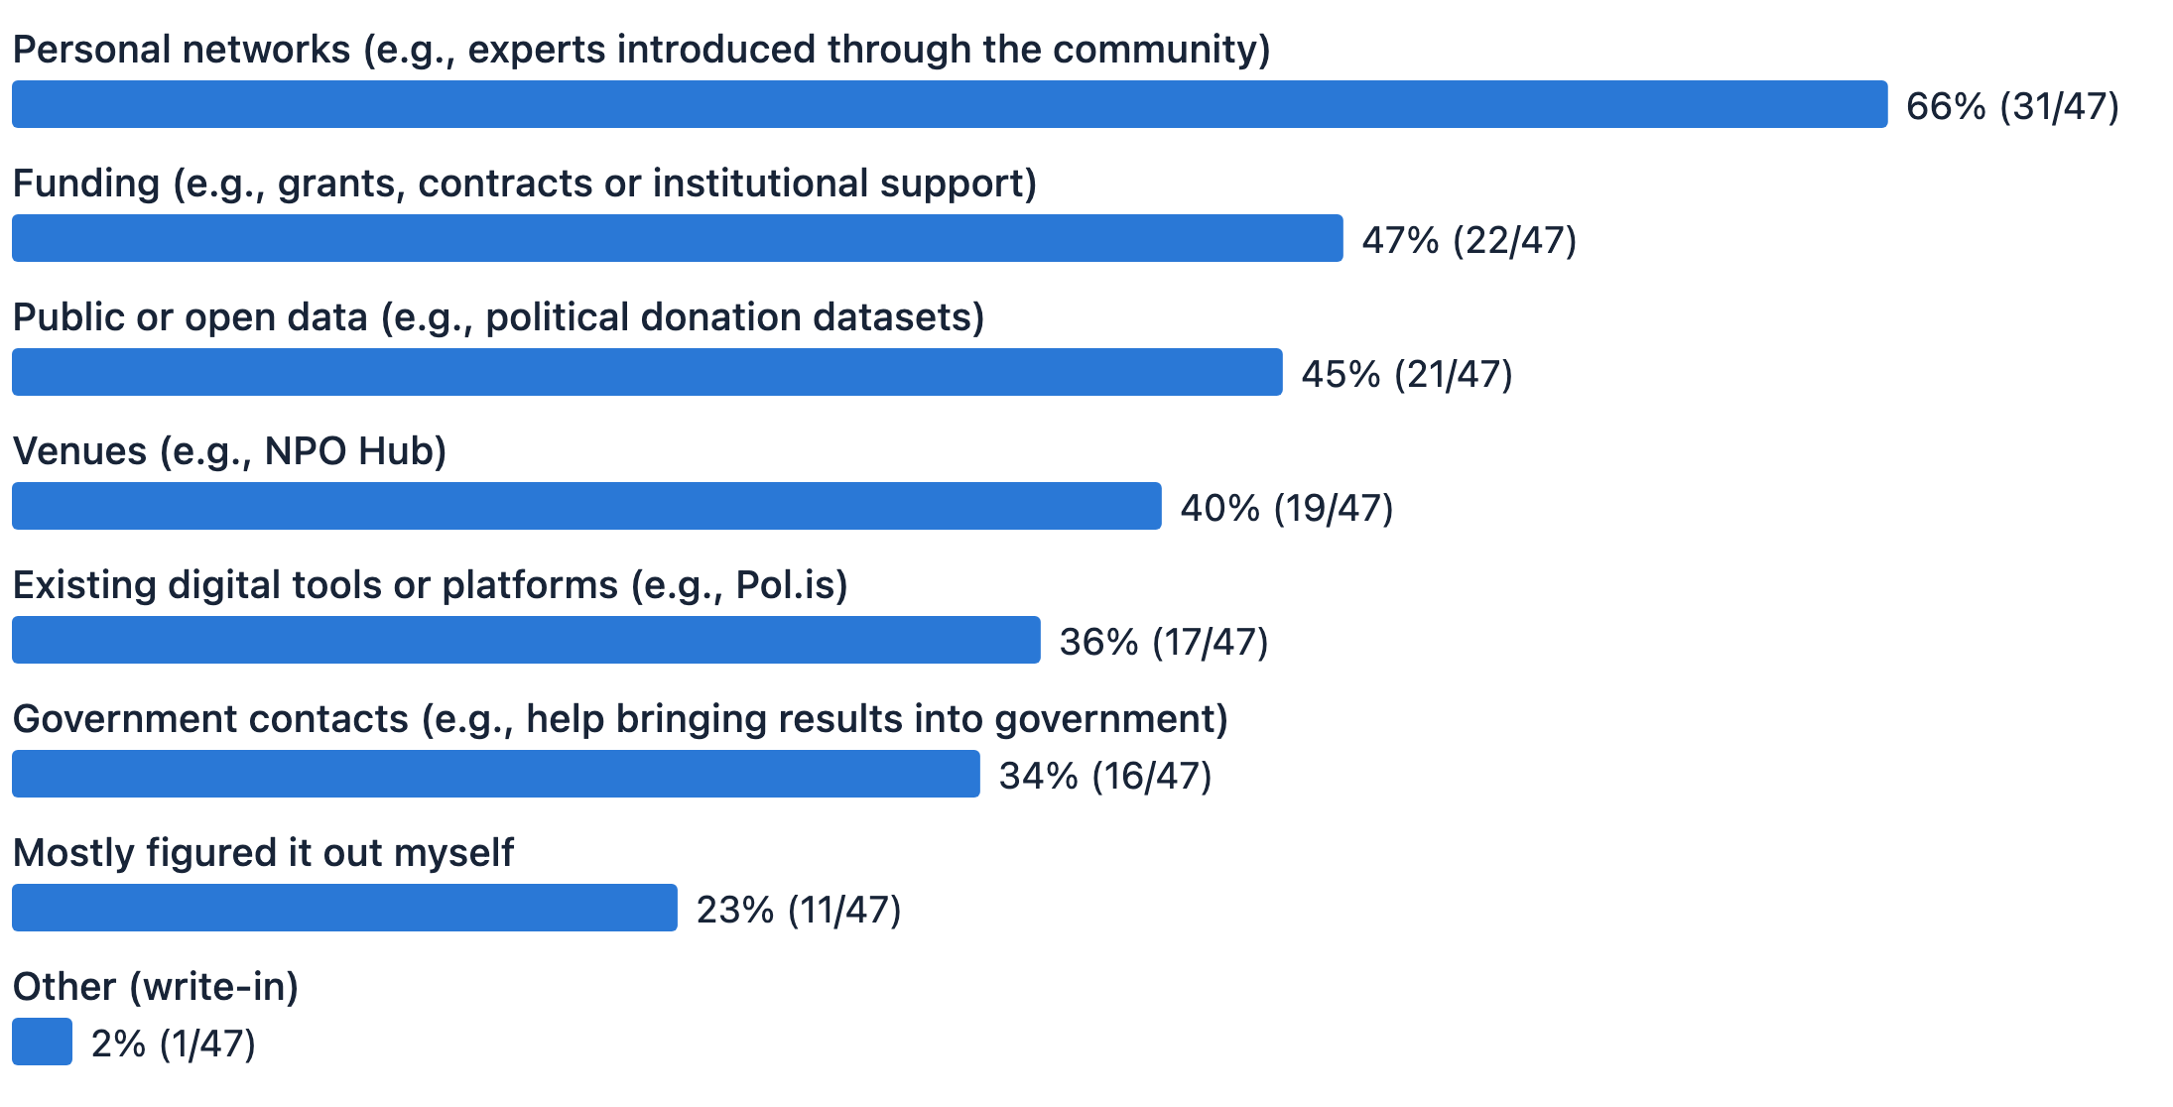
Base: 47 Builders
Which resources did the 47 Builders use on their most recent project? Personal networks came first, used by 66%, followed by "Funding" (47%), then public or open data (45%) and venues (40%). Another 23% said they "Mostly figured it out myself".

5.2 What skills do project members contribute most?
Key point: Topic research and project management are the most common skills (51% each); coding ranks only sixth (28%).
Skills the Builders have contributed
Base: 47 Builders (more than one answer allowed, so totals exceed 100%; many people do several things)
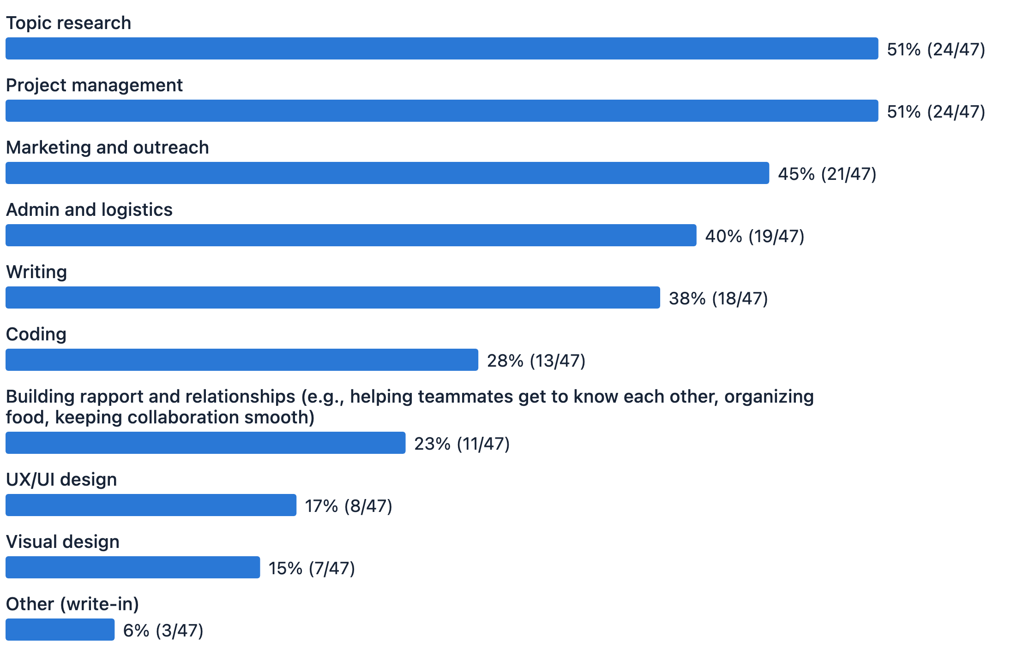
Base: 47 Builders
Skills project members contributed (more than one answer allowed): topic research and project management tie for first at 51% each, followed by marketing and outreach (45%), admin and logistics (40%) and writing (38%). Coding is sixth at 28%. The rest are building rapport and relationships (23%), UX/UI design (17%) and visual design (15%).
You don't have to code to take part in a project. As Chapter 7 shows, 35% of the 26 Curious who have not taken part listed "I'd need to know how to code; the bar is too high" as a reason for not joining. But among the 47 Builders, fewer than three in ten wrote code; more worked on researching the topic, managing progress, promoting results and writing. This echoes the pain point in Chapter 3, stalled progress. From this we can even infer that projects may need people who can manage more than people who can code.

5.3 More than half of the Builders spend five hours or less a month on their project
Key point: More than half of the Builders spend 5 hours or less a month on their project, but 21% spend 21 hours or more, close to a part-time job.
Asked how much time they spent on the project in the past 30 days: 1 to 5 hours was the most common answer (32%), followed by 6 to 20 hours and "almost none", tied at 23% each; 21 hours or more came to 21%.
More than half of the Builders spend less than 5 hours a month on their project, which echoes the problem in Chapter 3, "Progress is hard to keep steady": when most members move a project forward in spare moments, it is no surprise that progress comes in fits and starts. At the other end, 21% spend 21 hours or more a month, close to a part-time job. The community has both occasional contributors and people who are deeply committed.

6. Funders value "a clearly explained problem" most, and see early-stage ideas as the hardest to fund

6.1 How do funders assess projects?
Key point: Almost all 27 funders are already part of the community. What they value most is "a problem that is important and clearly explained", followed by a project that matches issues they care about.
What funders value most when assessing a project (27 funders, more than one answer allowed)
What they value most | Respondents
The problem it tackles is important and clearly explained | 59% (16/27)
It matches issues I care about | 52% (14/27)
The team's or founder's ability and credibility | 44% (12/27)
It is expected to have visible, measurable impact | 44% (12/27)
It has a long-term plan and won't stop when the money runs out | 41% (11/27)
I happened to have budget or resources at the time | 26% (7/27)

27 respondents have given financial support to civic tech projects. 27 is a small group, so the figures below show this group's tendencies and are best used as a starting point for understanding funders.
The factors received fairly similar levels of attention, except "I happened to have budget at the time", which was low. This suggests that most money supporting civic tech is planned. Projects seeking funding should keep track of possible funding sources, assess their impact, and explain clearly how they will solve the problem.
These 27 funders are almost all insiders: 20 have worked on a project, 6 have had contact with the community but not worked on a project, and only 1 has just heard of or seen civic tech. The money this survey captured comes mostly from people already in the community, not from outside funders.

6.2 At which stage do projects struggle most to find resources?
Key point: Funders think projects "still at a very early stage, just an idea" have the hardest time finding resources. For projects that already have a prototype, the fewest funders see finding resources as hard.
Of the 27 funders, 52% think projects "still at a very early stage, just an idea" have the hardest time finding resources, followed by projects "already launched and needing long-term upkeep" (37%). Projects that "have a prototype and are moving toward real-world use" are seen most positively: only 11% think they struggle to find resources. This ties in with Section 6.1: funders care about a clearly explained problem, and at the idea stage, without concrete results to show, it is harder to convince them.

7. More than half of those who have not taken part say it is because they don't know which projects or issues they could join

7.1 Where the way in is, and where it breaks
Key point: Official channels reach more people than friends and family do: of all 127 respondents, 65% have used at least one official channel, and 40% rely on friends or family.
Where respondents hear about g0v.tw events
All respondents, N=127 (more than one answer allowed). “Friends or family” and “g0v.tw social media” tie as the top single options (51 people each); the five official channels combined reach 65%, more than the 40% reached by friends or family
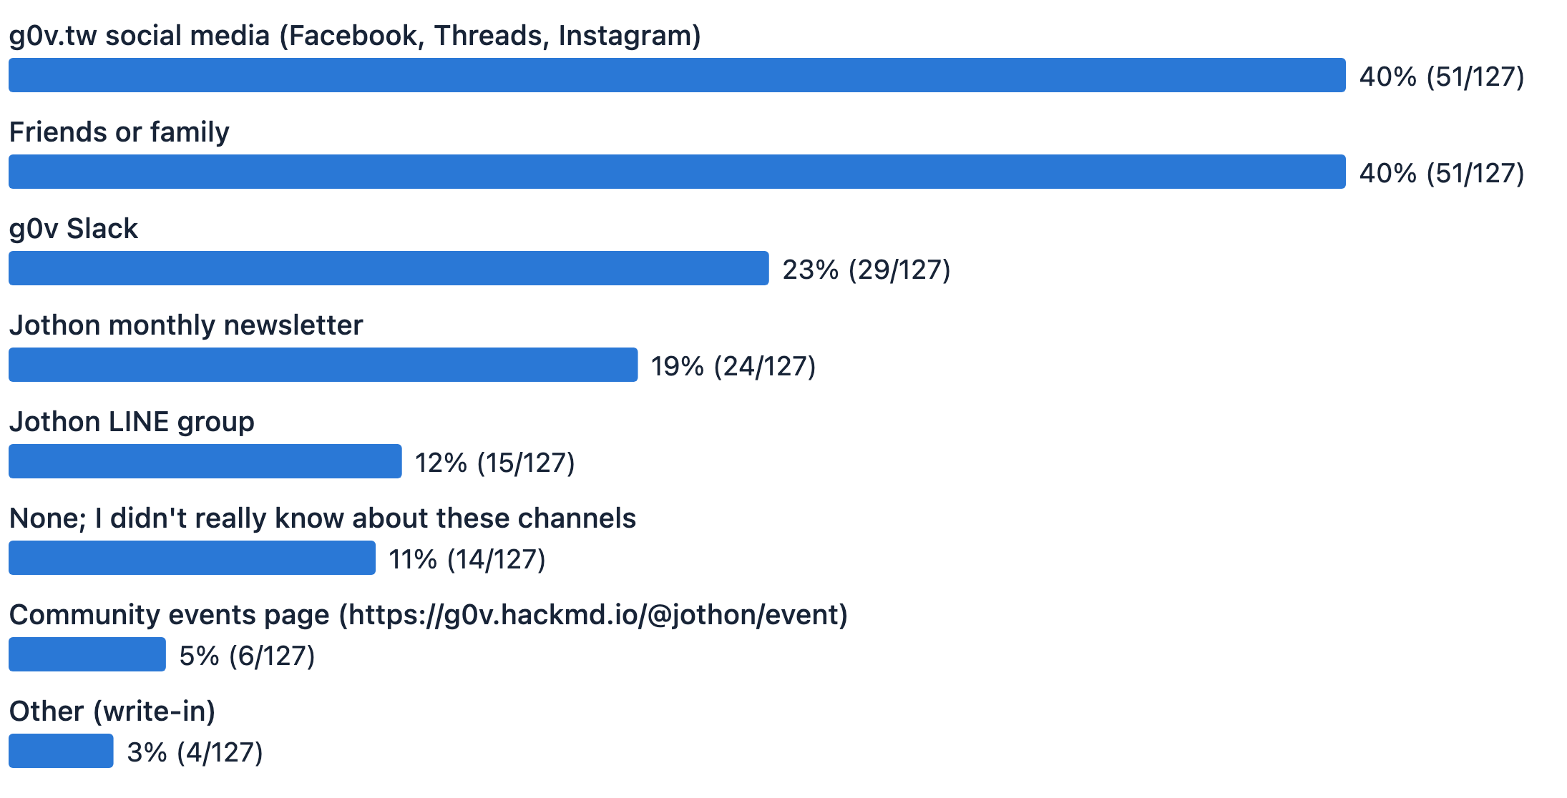
Base: all 127 respondents
 | Use at least one official channel | Rely on friends or family
All 127 respondents | 65% (83/127) | 40% (51/127)
The 47 Builders | 72% (34/47) | 47% (22/47)

For the multiple-choice question "Through which channels do you currently hear about g0v.tw events?", the top single options were g0v.tw's social media accounts (Facebook, Threads, Instagram) and friends or family, at 40% each, followed by g0v.tw's Slack (23%), Jothon's monthly newsletter (19%) and Jothon's LINE group (12%). Another 11% said "None; I didn't really know about these channels".
If we combine the five official channels (social media, Slack, newsletter, LINE group and the events page), counting each person only once, official channels clearly reach more people than friends and family do.

7.2 What is the main barrier for people who have not taken part in civic tech?
Key point: The top three barriers for newcomers are all about missing information and a way in, not ability. Worrying about not being able to code ranks only fourth.
What holds back people who have not taken part
Up to 3 choices. Base: the 26 Curious (the 54 Users were not asked this question)
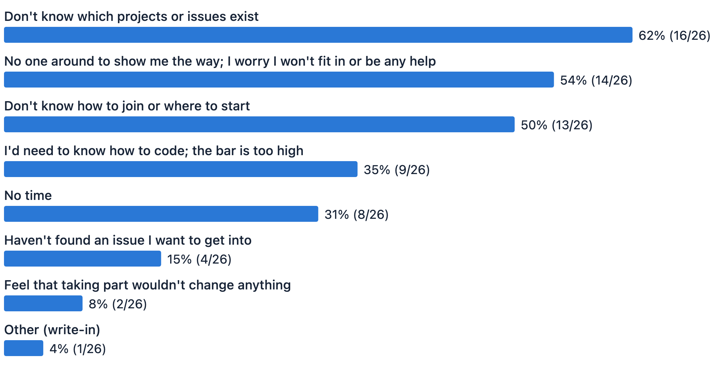
Base: the 26 Curious
Among the 26 Curious who have not taken part (up to 3 reasons each): the top three reasons are not knowing which projects or issues exist (62%, 16/26), having no one around to show the way and worrying about not fitting in or being any help (54%, 14/26), and not knowing how to join or where to start (50%, 13/26). All three are about missing information and a way in, not about ability. The stereotype that civic tech requires tech skills does not hold up: "I'd need to know how to code; the bar is too high" comes fourth, at 35% (9/26).

7.3 Which events do people at different stages want?
Key point: The Curious most want "Intro to the database"; the Builders most want "Working with government". Different groups need different things.
Which events each group most wants to attend
Up to 2 choices. Each bar shows the share of that group who chose it
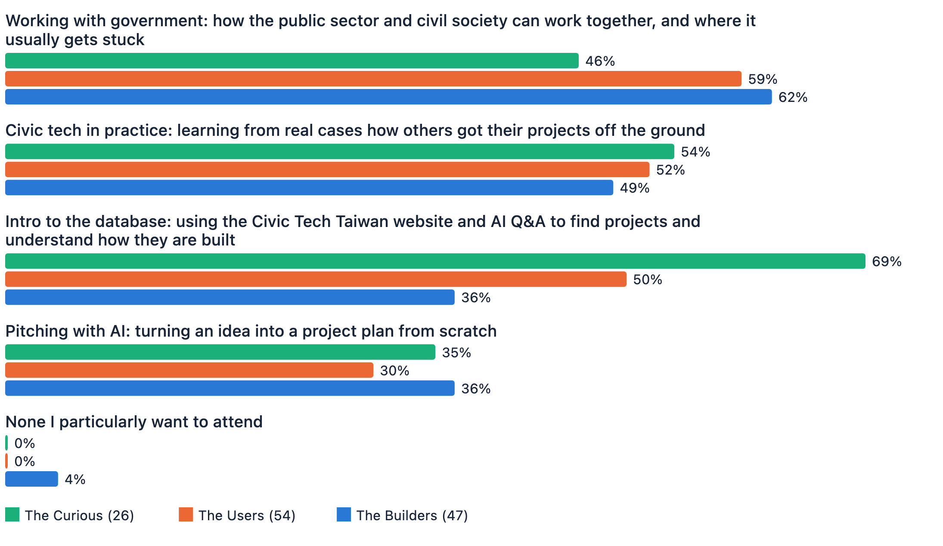
The Curious: 26, the Users: 54, the Builders: 47
The survey asked which events people would most like to sign up for (up to 2 choices). Across all respondents, the most popular was "Working with government" (57%), followed by "Civic tech in practice" (51%) and "Intro to the database" (49%). "Pitching with AI" was chosen least (33%).
Comparing the three groups shows different preferences. "Intro to the database" is the most popular among the 26 Curious, at 69% (18/26), but only 36% (17/47) among the 47 Builders, possibly because people already doing projects tend to know the existing projects and need an introduction less. "Working with government" is the opposite: it is the event the Builders most want (62%, 29/47), while demand among the 26 Curious is relatively low (46%, 12/26).
For community organizers, it helps to decide who an event is for before planning it: people who have not yet had contact with civic tech, people still standing at the door deciding whether to join, or people already working on projects?

IV. Recommendations

1. Two things to do first: help people find projects, and explain clearly how results can be put into real use

1.1 How to decide which topics to write about first
Key point: All five candidate article topics are "Attractive": having them is a plus, but not having them would not cause complaints.
We used Kano analysis (the Kano model), a method from product design that sorts features by how having or lacking them affects satisfaction, to see how respondents value the article topics g0v.tw Jothon is planning:
- Attractive: a pleasant surprise if it is there, no complaints if it is not. A bonus.
- Performance: the more you do, the more satisfied people are; without it, they are disappointed. The most reliable return on effort.
- Must-be: taken for granted if it is there, a source of dissatisfaction if it is not. A basic requirement; leaving it out feels like something is missing.
- Indifferent: people don't care either way. The lowest priority.
Where the five article topics fall in the Kano model (all respondents)
N=126 | Full SI range 0 to 1 and DSI range 0 to −1, with the 0.5 / −0.5 dividing lines in the middle. All five topics fall in “Attractive (A)”, with “Into real use” closest to the “Performance (O)” boundary
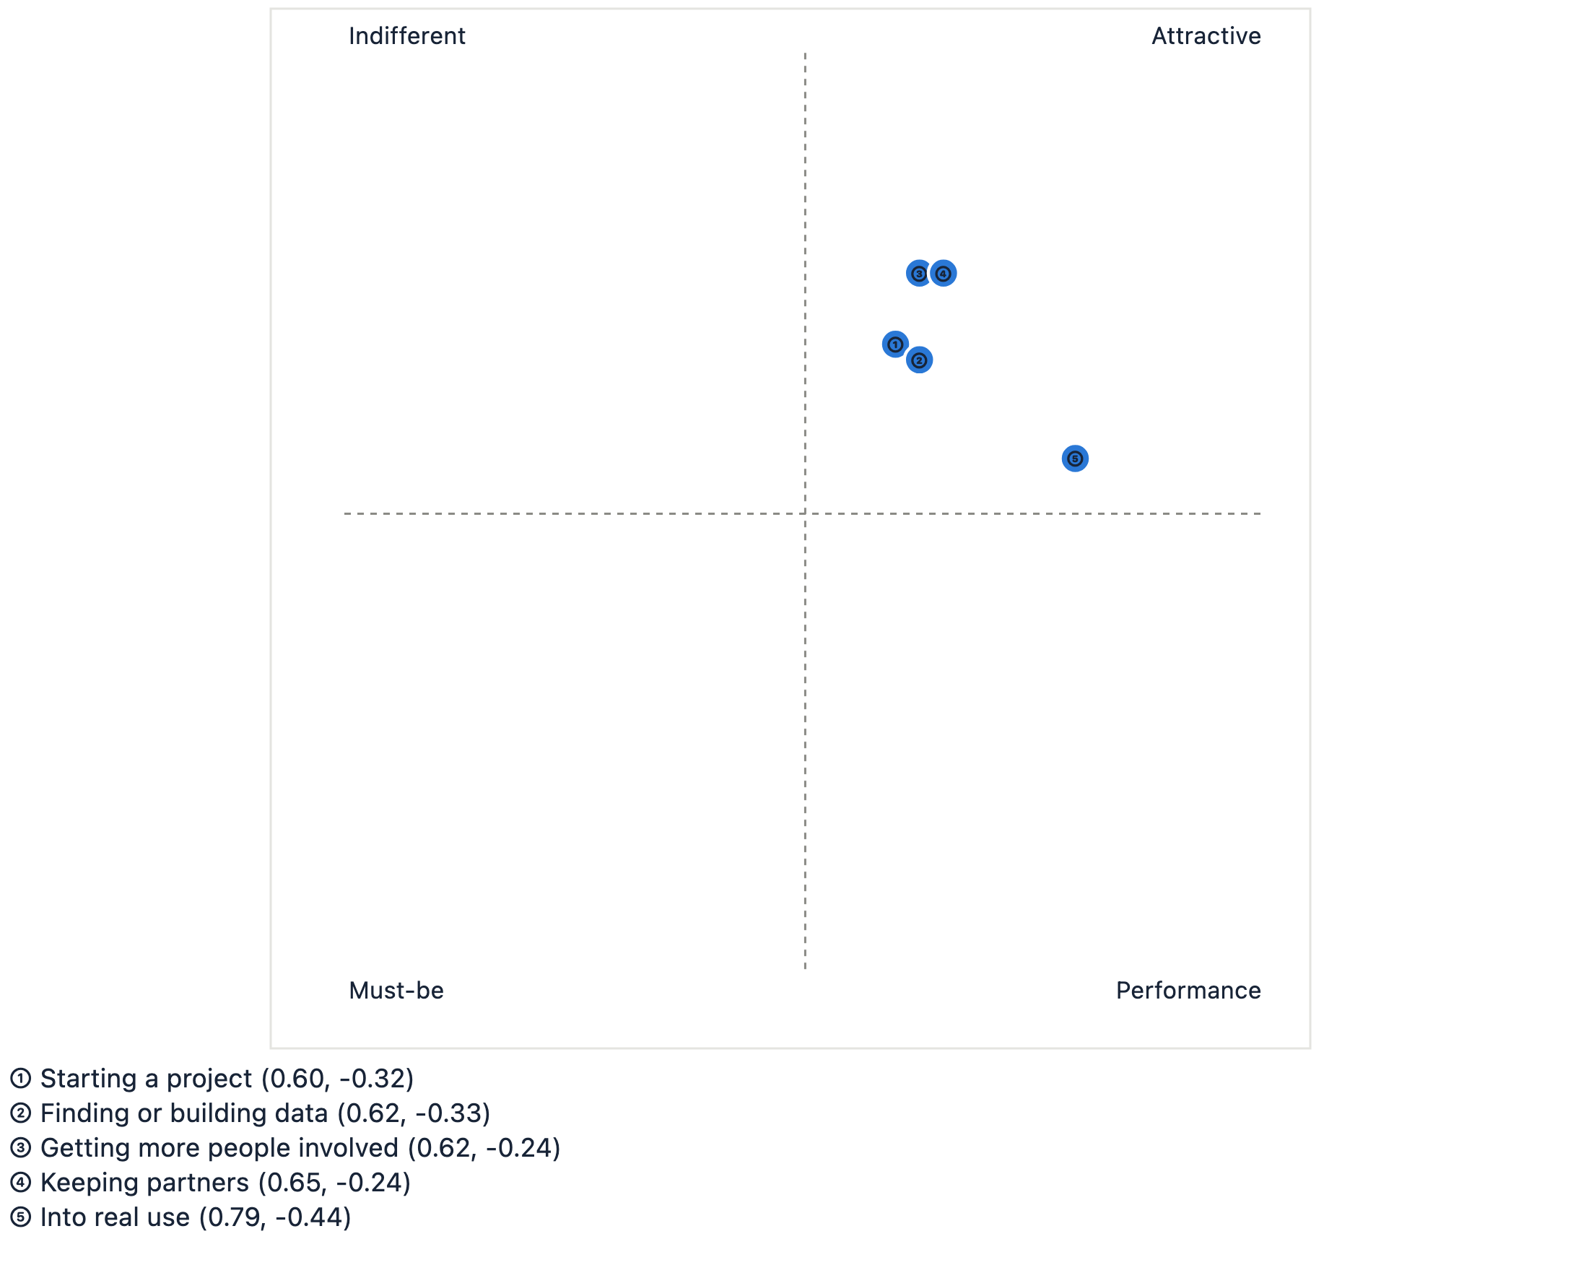
Base: 126 who answered (126 of the 127 respondents answered the Kano questions)
Which topics each group thinks are worth writing about
“Getting more people involved” ③ and “Keeping partners” ④ are “Indifferent” for the Curious but “Attractive” for both other groups: people who are not yet involved don't feel the pain of running a team
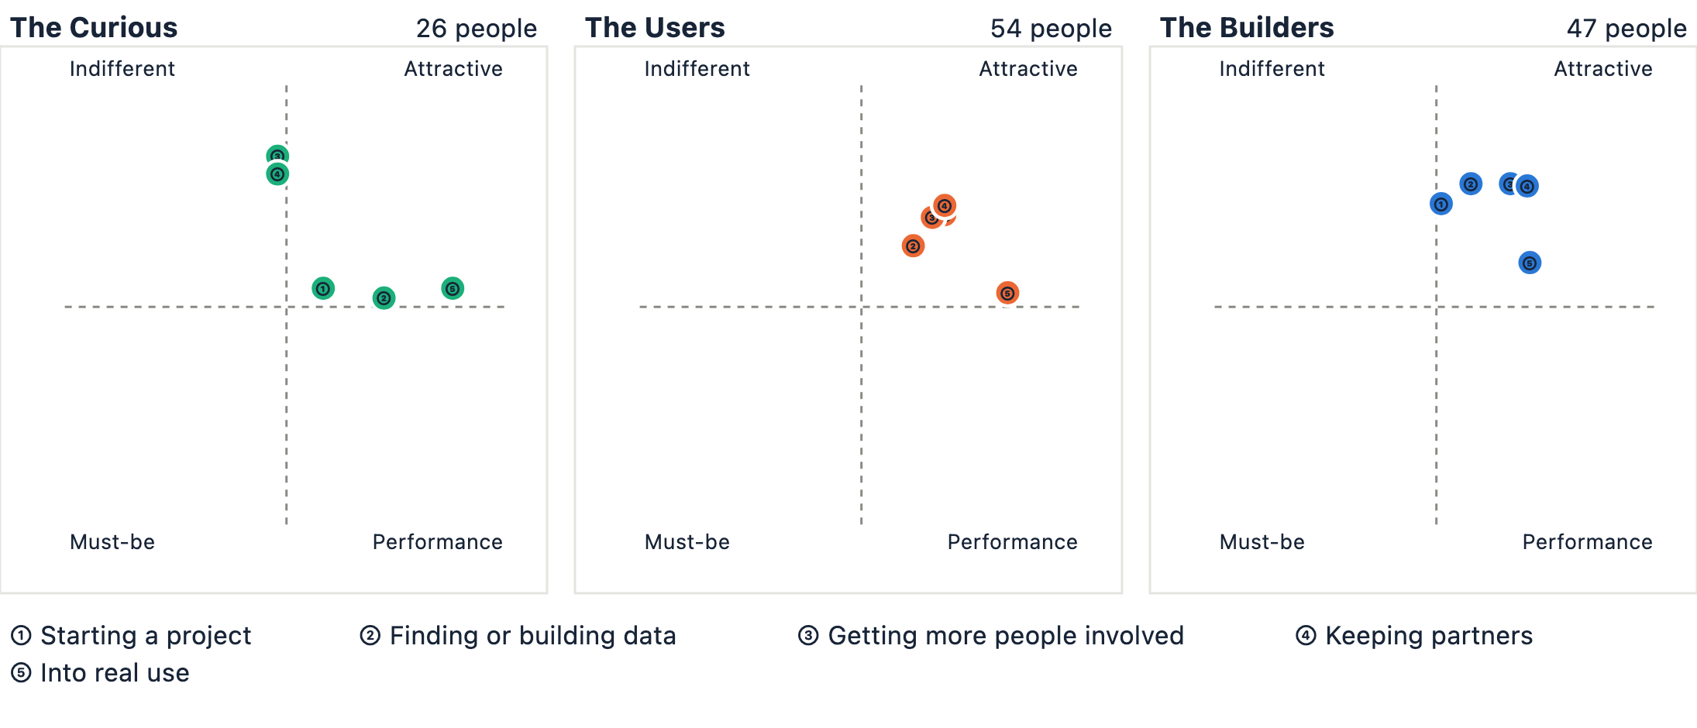
Each panel shows all four Kano quadrants; the same number means the same topic in all three panels
The results show that all five candidate article topics fall into "Attractive", with "How to get what you built into real use, including within government" closest to "Performance". These topics add value for respondents, but when they answered, none had reached the basic level of "people would complain if it were missing".
Looking at the three groups separately shows one difference: "How to get more people involved" and "How to keep partners" are "Indifferent" for the 26 Curious, who have heard of or seen civic tech but not got involved, yet "Attractive" for both other groups. This may reflect that people who have not engaged deeply with civic tech feel the pain of running a team and keeping it going less keenly.

1.2 Topics and tools: budgets and procurement, and crowdsourcing tools, are most wanted
Key point: Among cross-cutting tools, the most wanted introduction is "Crowdsourcing and reporting tools" (61%); among issue areas, the most wanted is "government budgets, spending and procurement" (54%).
Which issue areas each group most wants data lists for
Up to 5 areas | Share of each group who chose it (base: those in the group who answered) | There are 26 Curious
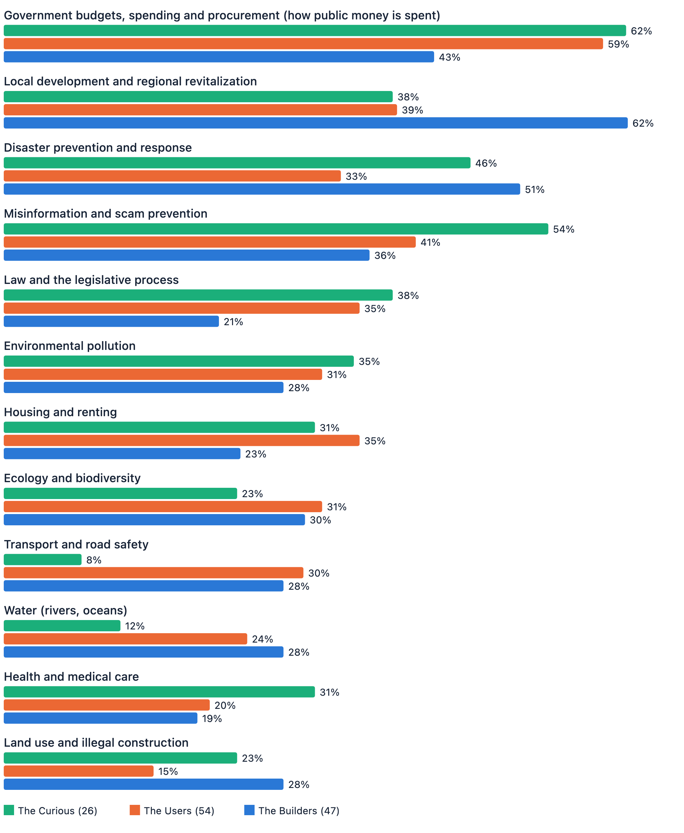
The Curious: 26, the Users: 54, the Builders: 47
Which cross-cutting tools each group most wants introduced
Up to 3 tools | Share of each group who chose it (base: those in the group who answered) | There are 26 Curious
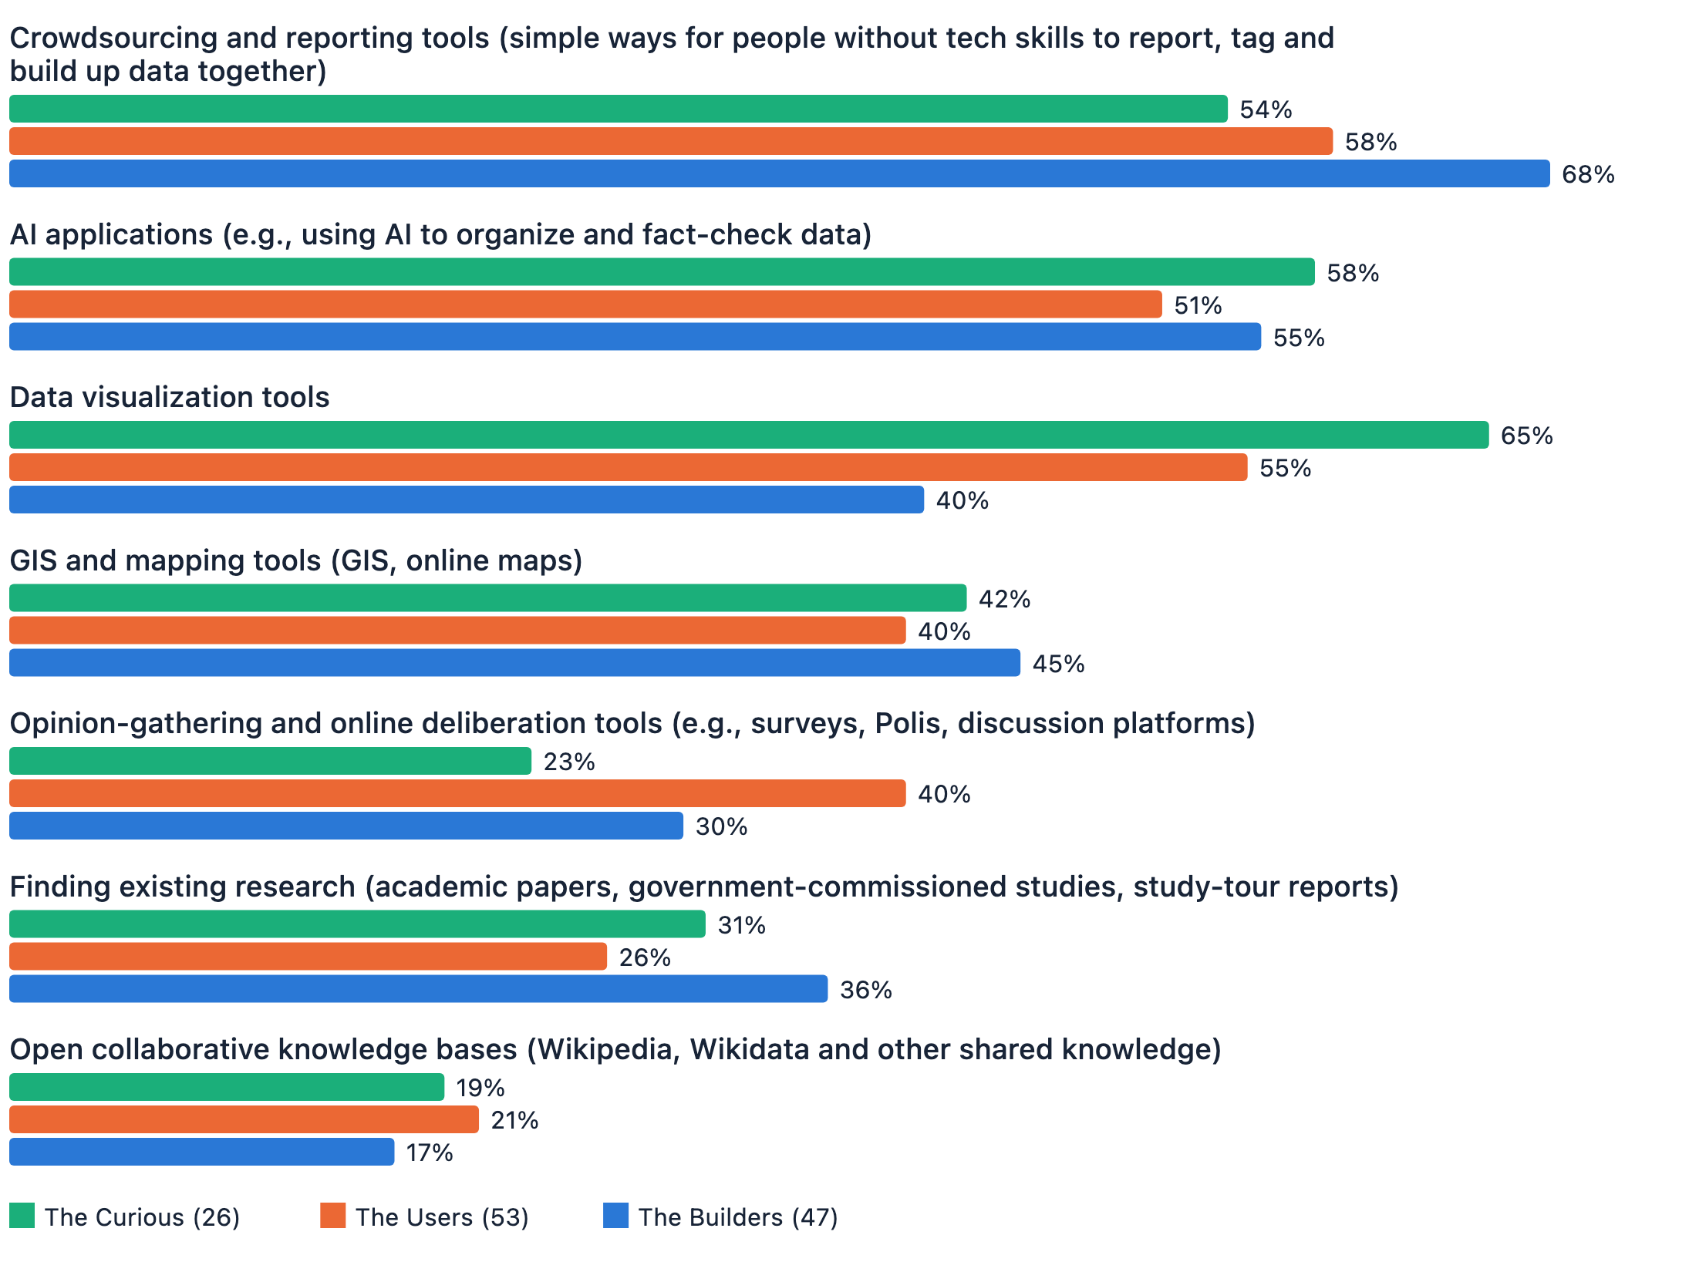
The Curious: 26, the Users: 54, the Builders: 47
Besides article topics, the survey asked which issue areas respondents most want data lists for, and which cross-cutting tools they most want introduced (both questions allowed more than one answer):
Cross-cutting tools: crowdsourcing and reporting tools were chosen most (61%), followed by AI applications (54%) and data visualization tools (52%), then GIS and mapping tools (42%), opinion-gathering and online deliberation tools (33%), finding existing research (31%), and finally open collaborative knowledge bases (19%).
Issue areas: the data lists respondents most want to see first are government budgets, spending and procurement (54%), local development and regional revitalization (47%), disaster prevention and response (43%), and misinformation and scam prevention (42%), with environmental pollution (31%) and law and the legislative process (31%) tied after them.
Comparing these tools and issue areas across the three groups shows that their needs and interests differ slightly.

1.3 Resources by stage: people get stuck in different places
Key point: At each stage of getting into civic tech, people get stuck in different places and need different resources.
The difficulties from the earlier chapters can be mapped onto the journey of someone getting into civic tech. At each stage, people get stuck in different places and need different kinds of support:
Stage | Where people get stuck | What people at this stage need
Not in yet | Don't know which projects or issues they could join 62%; don't know where to join 50% | A place to see the whole picture and find a way in
Want in, but no one to show the way | No one around to show the way, worried about not fitting in or being any help 54% | Settings where they can ask someone and work alongside others
Starting to build | All five article topics are "Attractive", with "how to get results into real use" the strongest | Other people's experience written up as guides they can follow
In the middle of a project | Don't know where to find data and tools (crowdsourcing 61%, AI applications 54%) | Collections of ready-made resources for each issue area and type of tool
All along the way | Stalled progress 38%, results that struggle to make a difference 36%, core members burning out 32% | Experience in keeping a steady pace and sharing the load

Chapter 7 shows that the biggest barrier for newcomers is not knowing which projects or issues they could join, not a lack of technical skill or ability. Civic Tech Taiwan, the database run by g0v.tw Jothon, already lists many projects and how-to guides. With these basics in place, the next question is: how can the database reach each newcomer at the right moment, just as they want to get started?
Newcomers' other big difficulty is "no one around to show the way". g0v.tw Jothon has tried many ways to connect first-timers at g0v.tw hackathons with experienced members, yet many people still hold back because they have no one to guide them. How could a better way of introducing newcomers be designed? Or does stepping through the door simply require newcomers to put in more effort themselves? These are questions worth continuing to explore.

1.4 How to support the ecosystem: early projects lack resources most, and networks are used more than money
Key point: Early projects lack resources most, personal networks are used more than money, and those with the most say are most likely to burn out: all three are worth noting for anyone who provides resources.
If you might provide resources, here are a few things from this survey worth knowing:
Early projects have the hardest time finding resources, and this comes from funders themselves. Chapter 6 shows that more than half of funders (14 of 27, 52%) think projects "still at a very early stage, just an idea" have the hardest time finding resources. If you are thinking about how to support this ecosystem, this is a place to start: the earlier the support, the scarcer it tends to be, and the more it may decide whether a good idea ever grows.
Support is not only money. Chapter 5 shows that personal networks are the resource Builders use most; more of them had used networks than funding. Introducing an expert to consult, connecting a team with the right government contact, or offering a space to meet are all forms of support that project teams have actually used.
Look out for the core members holding projects together. Chapter 3 found that the more say people have over a project's direction, the more likely they are to burn out: 6 of the 10 (60%) who started a project said core-member burnout clearly held back progress. Chapter 4 also found that the sense of belonging to the community fades the most over time. Taken together, these may be a reminder for anyone supporting a project over the long term: besides tracking results, it is worth checking whether the few people holding the team together can keep going.

V. Reflections

1. Alternative explanations for each conclusion
Each chapter offered another possible explanation alongside its main findings. This section brings these alternative explanations together, so readers can check them and judge which conclusions can be relied on and which are better treated as directions for further observation.
This report's conclusion | Another possible explanation
The 27 funders represent the views of funders (Chapter 6) | 26 of the 27 are already part of the community. The survey was shared through g0v.tw channels, so the funders it reached were mostly insiders. These are insiders' views, not those of outside funders such as foundations, companies or governments.
Personal networks are used more than funding (Chapter 5) | The question asked "which have you used", not "which are hardest to get". Networks may be used more simply because they are easier to come by; this does not mean funding is unimportant or not scarce.
The sense of belonging is the motive that fades most (Chapter 4) | The survey only reached people still in the community. If belonging really fails to keep people, those people may have left long ago and never answered the survey, so the drop may actually be underestimated.
People aged 41 and over stay mainly because they "believe in the goal" (Chapter 4) | This may be a generational difference, or it may be that those who stay have already been filtered: older people still in the community are more likely to be mission-driven to begin with.
What holds newcomers back is information, not technology (Chapter 7) | These 26 people have already heard of or seen civic tech, but not taken part; they are not the general public who have never heard of it. For people with no contact at all, the barriers may lie elsewhere.
Six in ten live in Taipei or New Taipei (Chapter 1) | This reflects a limit of the sample: the survey was shared through g0v.tw channels, and g0v.tw's in-person events have long been held in Taipei, so it cannot be taken as the community's real geographic spread.

Limitations to keep in mind
- The survey was shared through g0v.tw and related community channels, so respondents lean toward people already interested in civic tech. The conclusions apply only to these respondents, not to the general public.
- Results for questions answered by all 127 respondents are relatively stable. But project-level questions (stage, resources, difficulties, motives) were answered only by the 47 Builders; split further, each group has only a dozen or so people, so treat those results as directions worth checking again.
- All cross-tabulations show correlation, not causation.
- The live version of the difficulties question had no "not experienced" option, so average scores are systematically underestimated. The main measure is therefore always "3 or higher (3, 4 and 5 combined)".

License and data sources
- License: CC BY 4.0, by g0v.tw Jothon & Claire Cheng
- You are welcome to analyze the anonymized raw survey data yourself. It is licensed under CC BY 4.0, credited to the survey respondents ("臺灣公民科技推廣問卷填寫者"): go to the data sheet (in Chinese)
- To check any number in this report, the analysis code, summary data CSVs and re-runnable pipeline are all public in this GitHub repo
1. g0v.tw (零時政府) is an open source community in Taiwan that promotes civic tech. The name swaps the "o" in "gov" for a zero, to rethink the role of government from zero.
Taiwan Civic Tech Ecosystem and Needs Survey | Author: Claire Cheng (鄭婷宇) | CC BY 4.0, by g0v.tw Jothon & Claire Cheng
Data: 127 valid survey responses collected up to 20 July 2026 | Check every number in this report on GitHub

